WAIT Indicator 2025
Summary of the analysis by the Pharmaceutical Policy Directorate of NIHDI (situation as of 20/05/2025)

WAIT Indicator Data – EFPIA/IQVIA

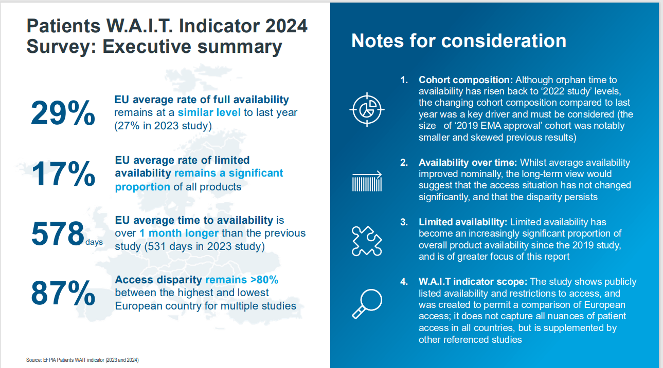

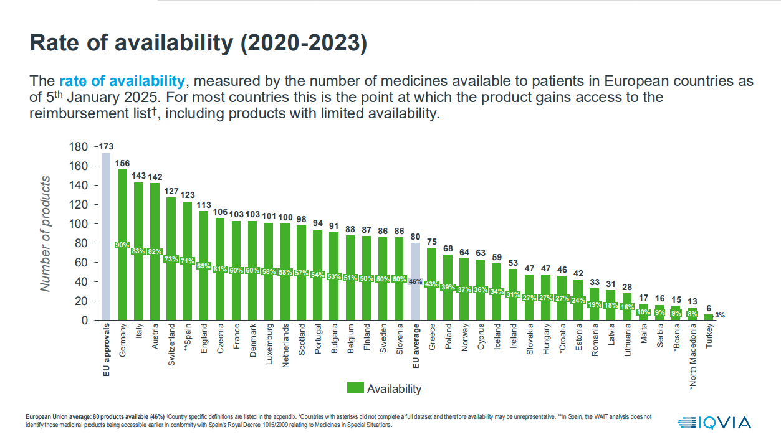

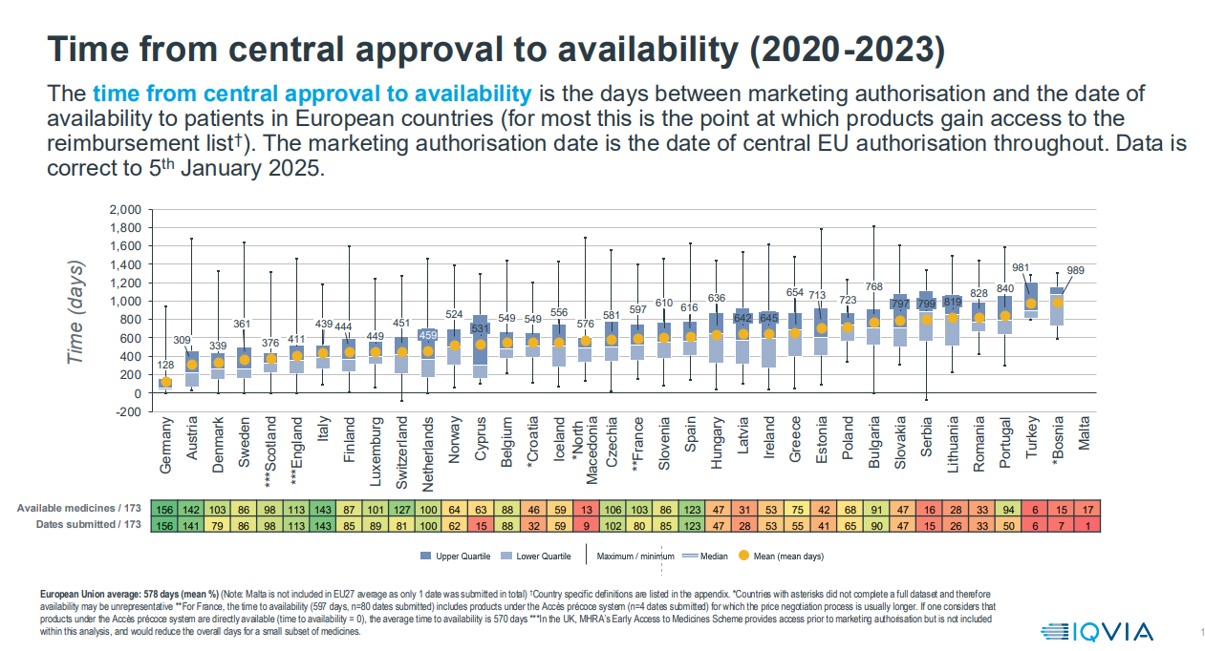

Main data from the EFPIA/IQVIA WAIT Indicator 2024 for Belgium
- 173 medicines were considered
- In Belgium, 88 of them are ‘available’ (= reimbursed)
- Average time between (centralised) marketing authorisation and reimbursement: 549 days
NIHDI Data – Pharmaceutical Policy Directorate

ACCESSIBILITY ANALYSIS

Of the 173 medicines included in the WAIT indicator, a reimbursement application was submitted in Belgium for 135 medicines (78%), while for 38 medicines this is (not yet) the case (22%).

Among the 135 medicines for which an application was submitted:
- 28 medicines (21%) were submitted in class 2 (no added value – at the request of the company),
- 58 medicines (43%) in class 1,
- 48 medicines (36%) in the orphan class,
- and 1 medicine (1%) in the radiopharmaceutical class.

Among these 135 medicines:
- 92 are already reimbursed (68%),
- 2 dossiers (1%) were reimbursed in the past but were withdrawn from reimbursement at the company’s request,
- 18 dossiers (13%) are still under evaluation,
- 23 dossiers have been closed (and have not [yet] been resubmitted), including:
  - 10 dossiers (7%) with a negative decision,
  - 2 dossiers (1%) due to absence of submission or lack of response after suspension,
  - 11 dossiers (8%) following voluntary withdrawal by the company.

 | Closed | Currently Reimbursed | Has been reimbursed | Not Reimbursed | Ongoing | Withdrawn | Grand Total
Class 1 | 1 | 36 | 1 | 7 | 6 | 7 | 58
Class 2 | 0 | 22 | 1 | 1 | 4 | 0 | 28
Orphan | 1 | 33 | 0 | 2 | 8 | 4 | 48
Radiopha | 0 | 1 | 0 | 0 | 0 | 0 | 1
Grand Total | 2 | 92 | 2 | 10 | 18 | 11 | 135
Figure 1: type of application and status – WAIT indicator
 | Closed | Currently Reimbursed | Has been reimbursed | Not Reimbursed | Ongoing | Withdrawn | Grand Total
Class 1 | 1% | 27% | 1% | 5% | 4% | 5% | 43%
Class 2 | 0% | 16% | 1% | 1% | 3% | 0% | 21%
Orphan | 1% | 24% | 0% | 1% | 6% | 3% | 36%
Radiopha | 0% | 1% | 0% | 0% | 0% | 0% | 1%
Grand Total | 1% | 68% | 1% | 7% | 13% | 8% | 100%
Figure 2: type of application and status – in percentage (WAIT indicator – submitted dossiers only)

Of the 35 new medicines included in the current WAIT indicator compared to the previous analysis:
- 10 have not (yet) been the subject of an application,
- 18 are already reimbursed,
- 6 dossiers are still under evaluation,
- and 1 dossier has been closed (withdrawn by the company).

 | Currently Reimbursed | Ongoing | Withdrawn | Grand Total
Class 1 | 6 | 2 |  | 8
Class 2 | 8 | 2 |  | 10
Orphan | 4 | 2 | 1 | 7
Grand Total | 18 | 6 | 1 | 25
Figure 3: type of application and status – WAIT indicator

PROCESSING TIME ANALYSIS

 | TIME TO CLAIM | TIME TO REIMBURSEMENT | DURATION OF PROCEDURE
 | Average | Average | Average
Class 1 | 98 | 549 | 336
Class 2 | 156 | 470 | 278
Orphan | 128 | 628 | 362
Radiopha | 273 | 479 | 206
Grand Total | 124 | 556 | 329
Figure 4: time to submission (CLAIM), time to reimbursement and duration of the procedure (including suspensions)

Figure 4 above provides a (detailed) overview of the time for the medicines included in the WAIT indicator:

- Between the first marketing authorization of the medicines (EMA data) and the FIRST reimbursement application (for medicines currently reimbursable).
This period is on average 124 days.

- Between the first marketing authorization of the medicines (EMA data) and the FIRST reimbursement (regardless of the number of procedures undergone or resubmission loops). This period is on average 556 days.
These 556 days therefore include:

    - the waiting time for the company to submit the application (TIME TO CLAIM), only for medicines currently reimbursable:
98 days for class 1 medicines, 156 days for class 2 medicines, 128 days for orphan medicines, and 273 days for radiopharmaceutical specialties;

    - suspensions due to inadmissibility (3.8 days);

    - suspensions of the dossier during the reimbursement procedure (response to the evaluation report, price not yet available from Economic Affairs, response to the provisional proposal, etc.), as well as time for contractual negotiations (161 days);

    - the duration of the reimbursement procedure (maximum 180 calendar days, excluding suspensions);

    - the time between potential successive procedures (resubmissions);

    - the time between notification of the decision and its entry into force, following publication in the Belgian Official Gazette (2 months).

- Between the reimbursement application (leading to a positive decision) and the FIRST reimbursement (regardless of the number of procedures undergone or loops), i.e. the duration of the reimbursement procedure, including suspensions.
This period is on average 329 days.

